SEMESTER TWO
Papers written by Australian Maths Software

YEAR 11
MATHEMATICS SPECIALIST
Units 1 & 2
2016
REVISION 3
Section Two
(Calculator–assumed)

Name: __________________________________

Teacher: ________________________________

TIME ALLOWED FOR THIS SECTION

Reading time before commencing work: 10 minutes
Working time for section: 100 minutes

MATERIAL REQUIRED / RECOMMENDED FOR THIS SECTION

To be provided by the candidate
Standard items: pens, pencils, pencil sharpener, highlighter, eraser, ruler.

Special items: drawing instruments, templates, notes on up to two unfolded sheets of A4 paper, and up to three calculators approved for use in examinations.

IMPORTANT NOTE TO CANDIDATES
No other items may be taken into the examination room. It is your responsibility to ensure that you do not have any unauthorised notes or other items of a non–personal nature in the examination room. If you have any unauthorised material with you, hand it to the supervisor before reading any further.

To be provided by the supervisor
Question/answer booklet for Section Two.
Formula sheet retained from Section One.
Structure of this examination

 | Number of questions available | Number of questions to be answered | Working time (minutes) |  | Marks available | Percentage of exam
Section One  Calculator—free | 7 | 7 | 50 |  | 52 | 35
Section Two  Calculator—assumed | 11 | 11 | 100 |  | 98 | 65
Total marks |  |  |  | 150

Instructions to candidates

1. The rules for the conduct of this examination are detailed in the Information Handbook. Sitting this examination implies that you agree to abide by these rules.

2. Write your answer in the Question/Answer booklet.

3. You must be careful to confine your responses to the specific questions asked and to
follow any instructions that are specific to a particular question.

4. Spare pages are provided at the end of this booklet. If you need to use them, indicate in the original answer space where the answer is continued i.e. give the page number.

5. Show all your working clearly. Your working should be in sufficient detail to allow your answers to be checked readily and for marks to be awarded for reasoning. Incorrect answers given without supporting reasoning cannot be allocated any marks. For any question or part question worth more than two marks, valid working or justification is required to receive full marks. If you repeat an answer to any question, ensure that you cancel the answer you do not wish to have marked.

6. It is recommended that you do not use pencil, except in diagrams.

7. The Formula Sheet is not to be handed in with your Question/Answer booklet.

Section Two: Calculator–assumed 98 marks

This section has eleven (11) questions. Attempt all questions.
Working time: 100 minutes
Question 8 (7 marks)
(a) Three little boys are pulling the dog’s tail. The dog seems to understand they are little, but if they pull with a combined force of 10N against the dog, he will snap and possibly bite them.
The forces exerted by the young lads are shown in the diagram below.



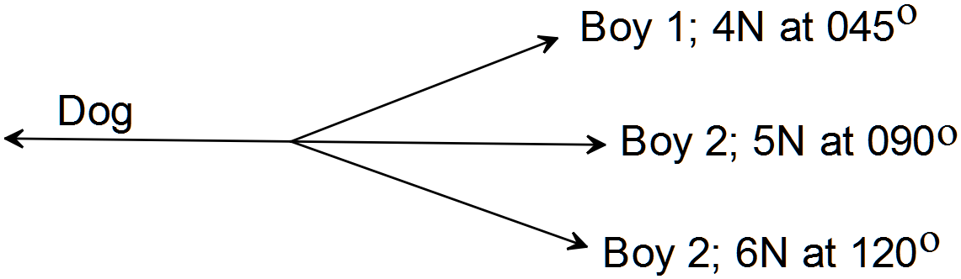
(i) What is the resultant force in the direction against the dog? (2)

(ii) Are the boys in danger from the dog? (1)

(b) Use a vector proof to show that
“The midpoints of the sides of a quadrilateral join to from a parallelogram.” (4)

Question 9 (8 marks)
(a) Simplify 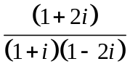. (3)

(b) Given 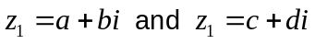
(i) Find 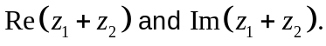 (3)

(ii) Show that 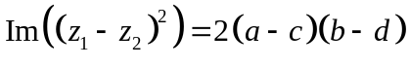 (2)

Question 10 (14 marks)
(a) (i) Express 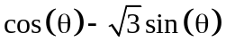in the form of 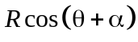for R > 0 and
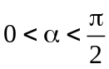. (3)

(ii) Hence solve 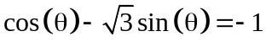 for , correct to two decimal places, on the domain 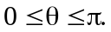 (4)

(b) Write down the equation of the function graphed below. (2)
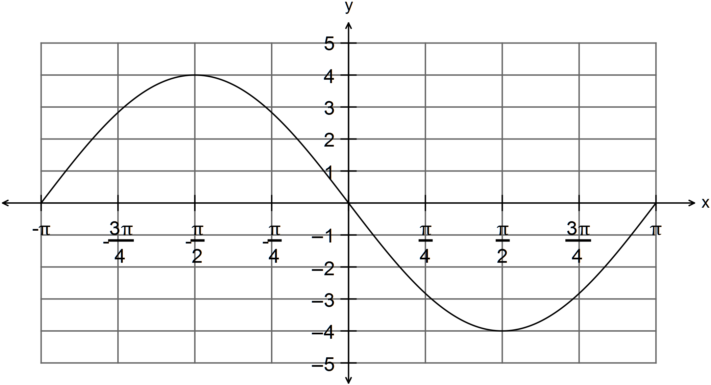

(c) Given 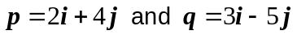
find
(i) 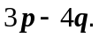 (2)

(ii) the vector in the same direction as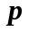but that has a magnitude of 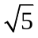. (3)

Question 11 (6 marks)
Consider the two functions 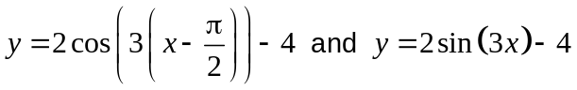.
(a) Are the functions equivalent functions? Explain carefully. (3)

(b) Sketch the function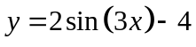 on the set of axes below: (3)

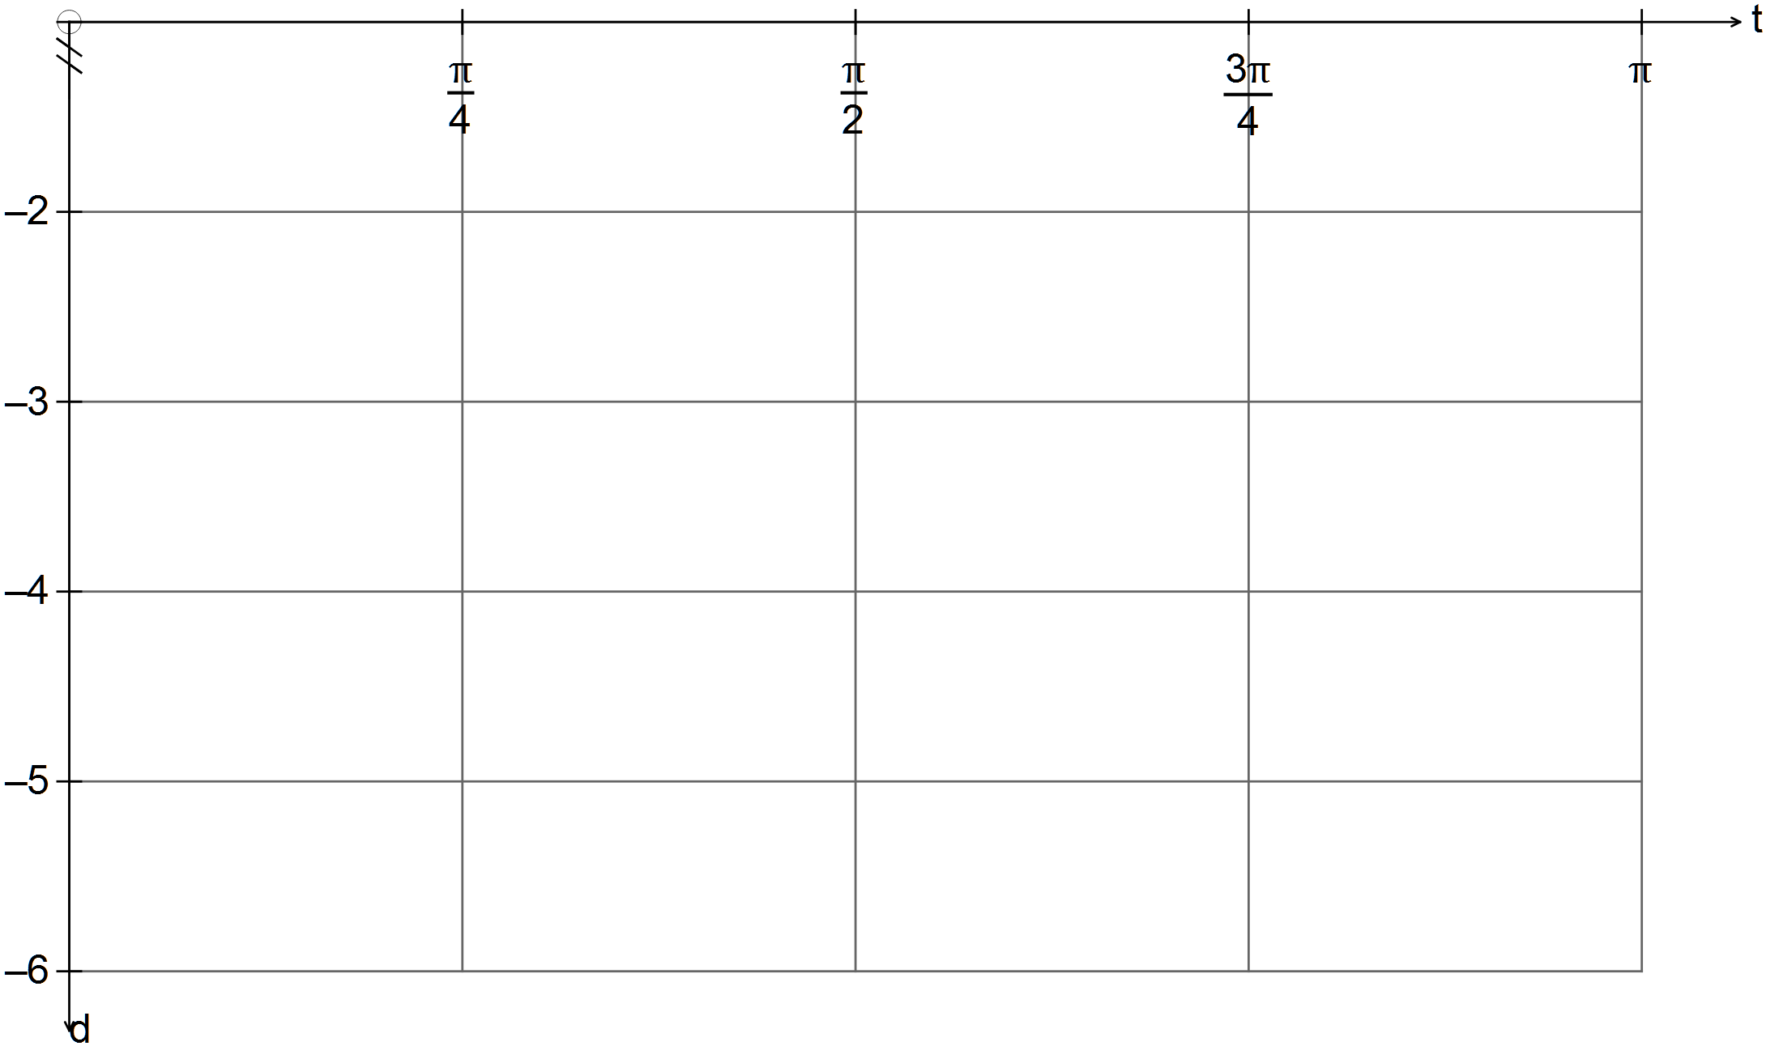

Question 12 (3 marks)
(a) Simplify (2)

(b) Hence show that (1)

Question 13 (11 marks)
(a) Solve the following equation 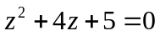. Show all working. (3)

(b) Find the complex number u such that 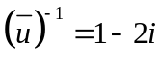. (3)

(c) A quadratic equation with real coefficients has one of its roots equal to 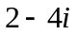.
Determine the quadratic equation. (3)

(d) Write the converse of the statement “If you study hard, you will pass your exams.”
(1)

(e) Write the contrapositive of the statement
“If you have a TV, then you are can watch the news on Channel Two.” (1)

Question 14 (9 marks)
(a) Find real x and y given 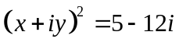. (4)

(b) (i) Solve for and , giving reasons. (2)
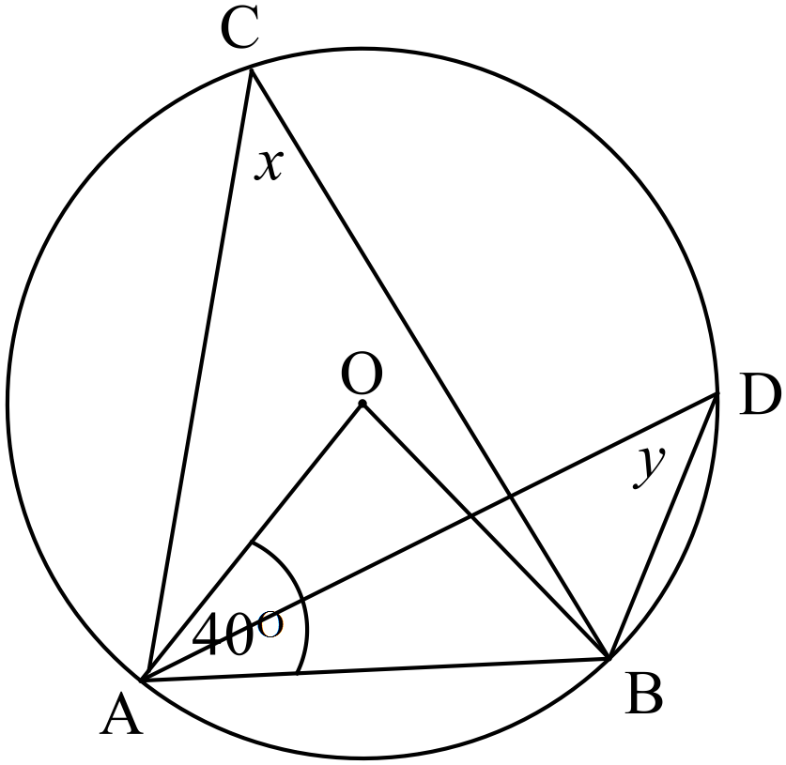

(ii) Solve for and , giving reasons. (3)
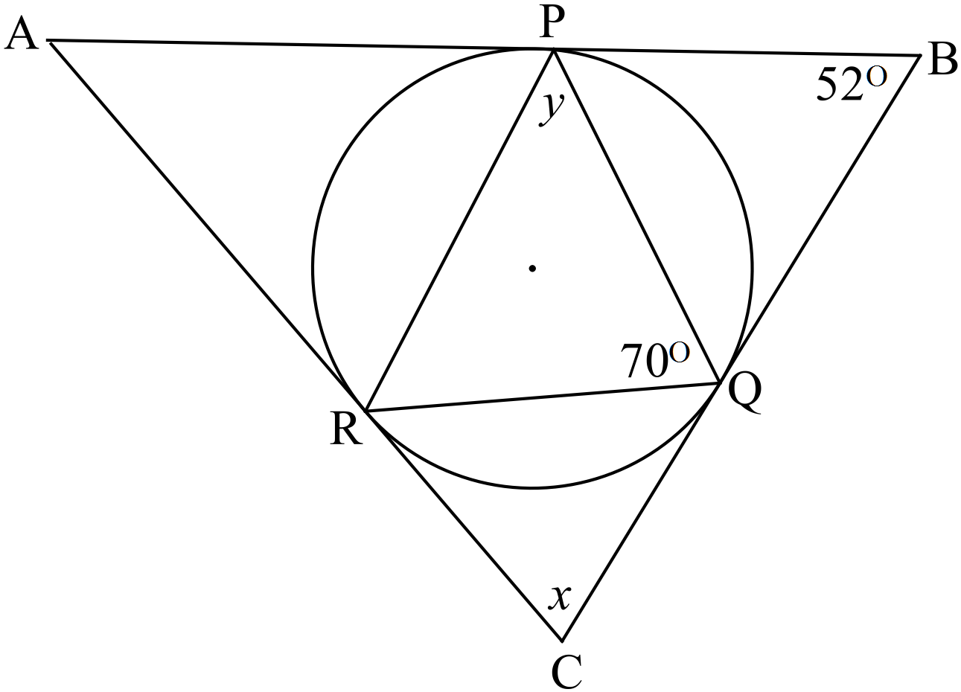

Question 15 (10 marks)
(a) There are 9 people that need to take a seat in a row of 12 chairs.
Show that there are at least three people seated in adjacent chairs. (2)

(b) (i) In how many ways can students gain first, second and third positions if 8 students
entered the competition? (1)

(ii) If the three prize winners are given identical tickets to the cinema. How many
different groups are there that could go to the cinema? (1)

(c) Among the 18 students in Mr Bean’s Maths class, 7 had black hair, 10 had blue eyes,
and 10 were considered tall. Also, 3 had black hair and had blue eyes, 4 had black hair and were considered tall, and 5 had blue eyes and were considered tall. One student had black hair, blue eyes and was considered tall.

(i) How many of these students did not have black hair, did not have blue eyes and
were not considered tall? (2)

(ii) How many of the students had blue eyes but not black hair? (1)

(d) Prove that 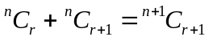 (3)
Question 16 (10 marks)
(a) Prove, using a proof by contradiction, that is an irrational number. (6)

(b) Prove using mathematical induction, that 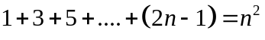
for any integer 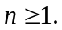 . (4)

Question 17 (12 marks)
(a) Consider the rectangle ABCD as shown in the diagram below.
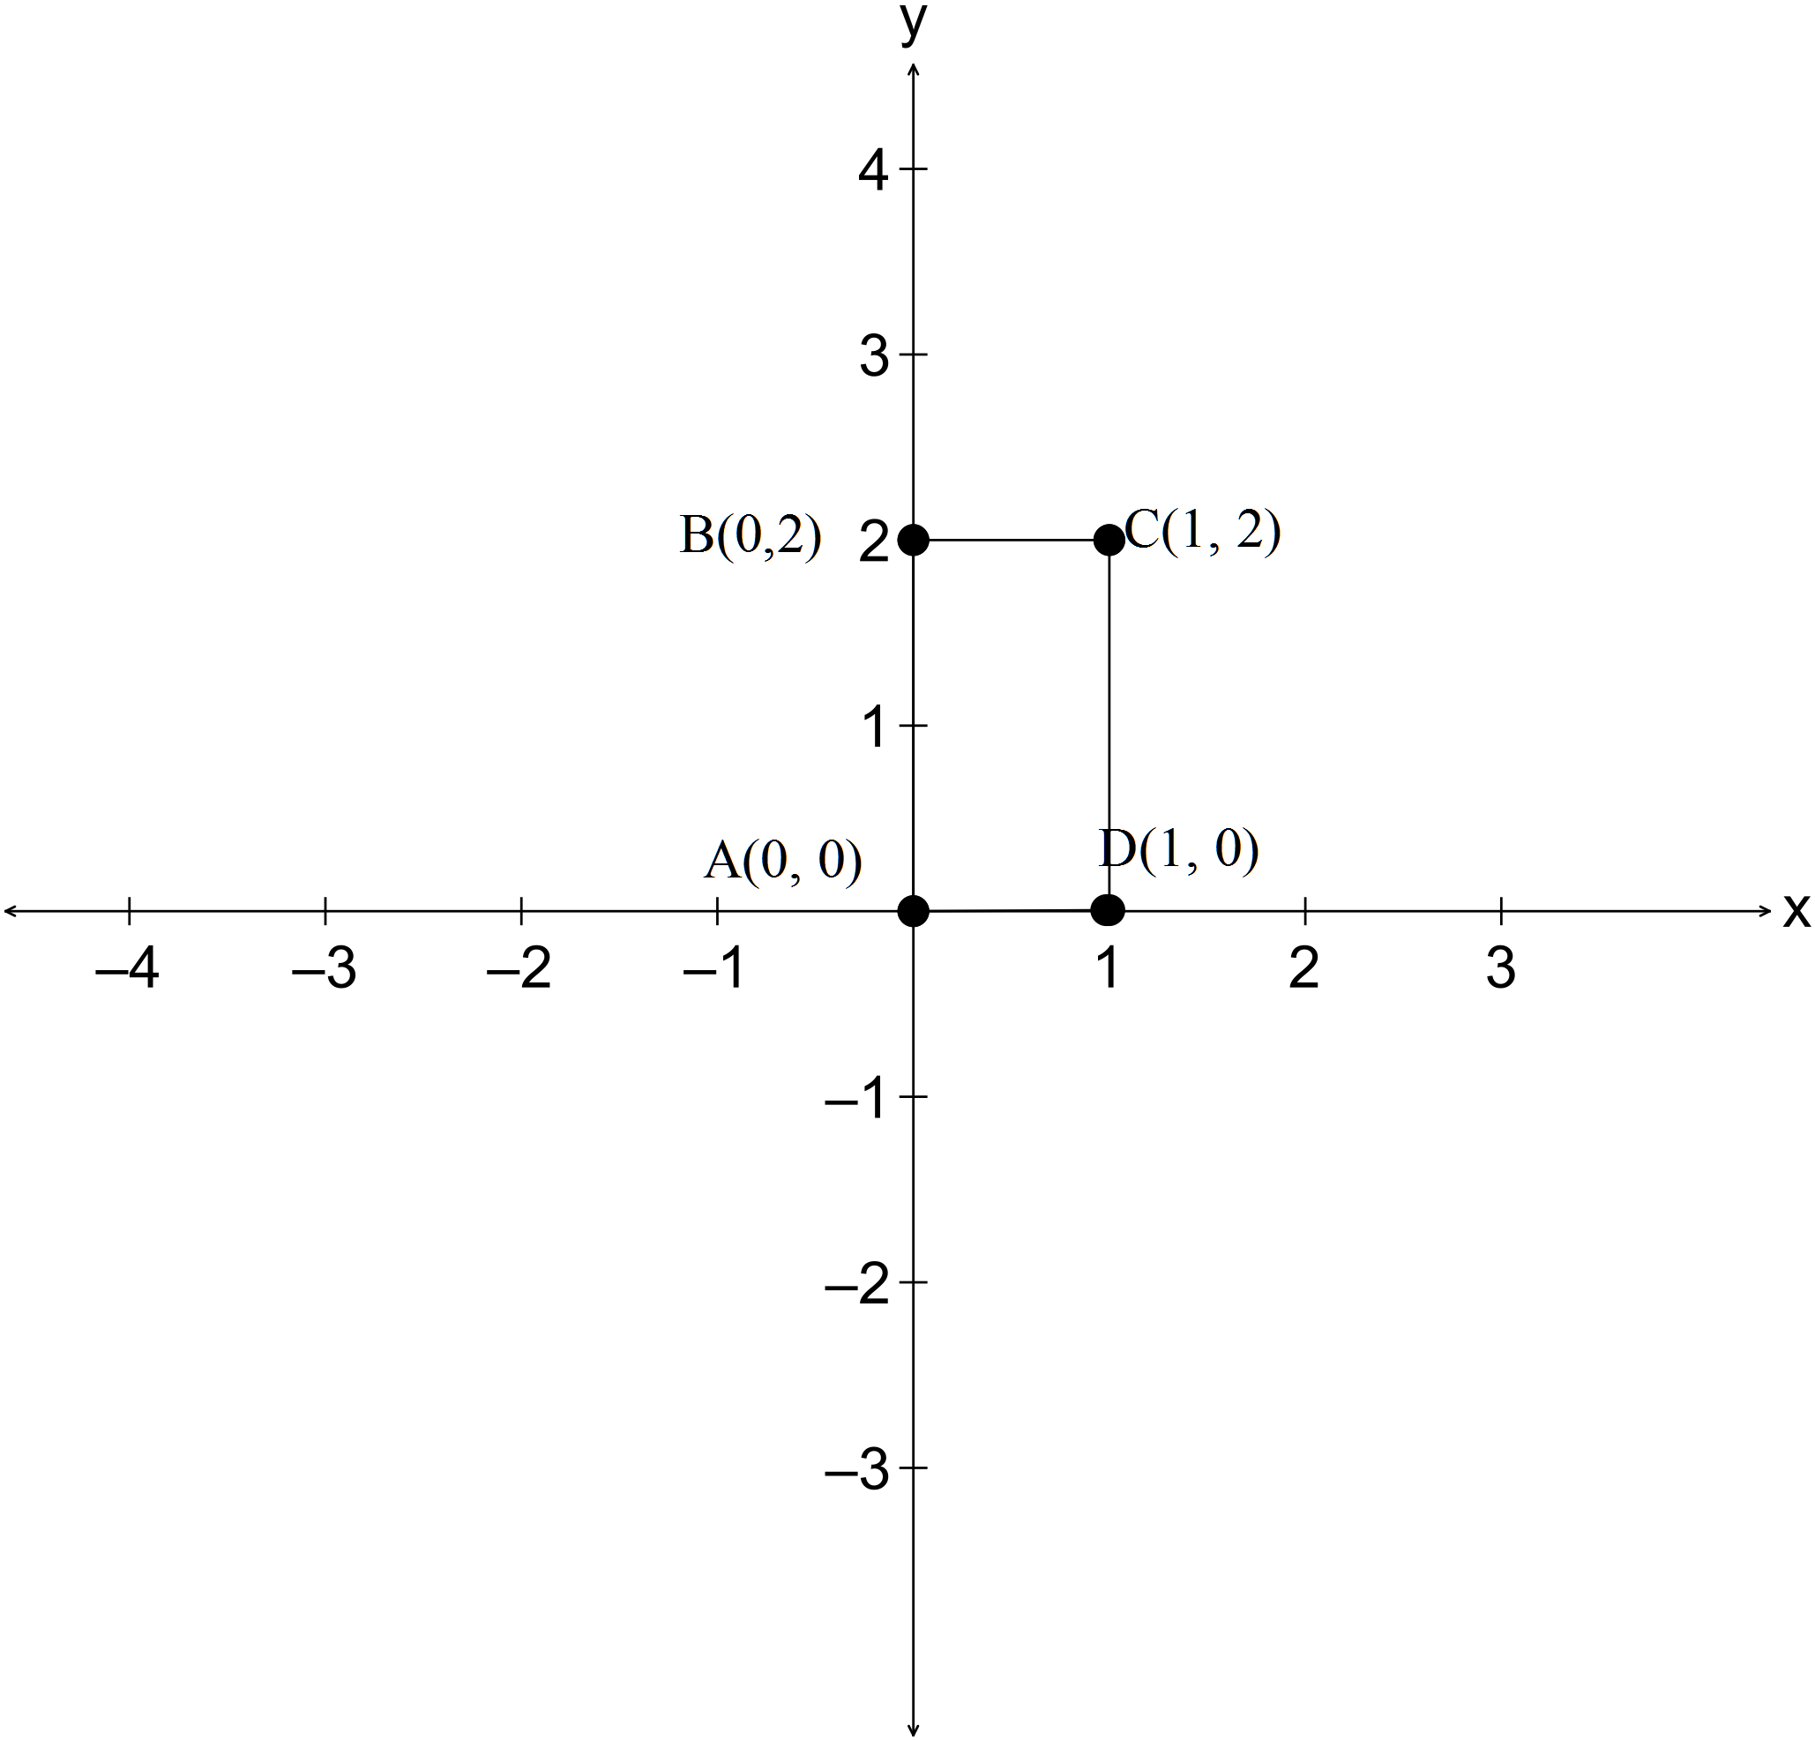
(i) Write down the matrix that transforms the coordinates A, B, C and D into the coordinates A’, B’, C’ and D’ as shown in the diagram below (1)

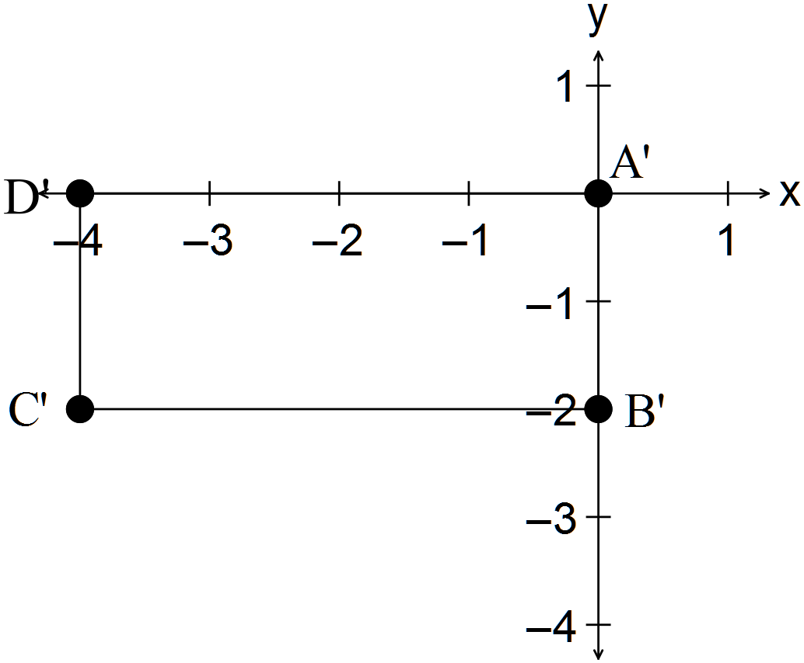

(ii) The rectangle A’ B’ C’ D’ is rotated 90º anti-clockwise about the origin to form
A’’B’’C’’D’’. Write down the rotational matrix. (1)

(iii) Determine the coordinates of the rectangle A’’B’’C’’D’’. (2)

(iv) Determine the single matrix that could have been used to change ABCD into A’’B’’C’’D’’. (2)

(v) Determine the matrix that could be used to transform A’’B’’C’’D’’ back into the rectangle ABCD. (2)

(b) (i) Explain how the area of the rectangle A’’B’’C’’D’’ can be calculated from the area of
the rectangle ABCD using the single transformational matrix found in (a) (iv). (2)

(ii) Verify that the method works. (2)

Question 18 (8 marks)

It is known that the matrix M performs a reflection about the line 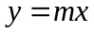
where

The point 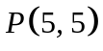is reflected about the line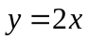and then that point is reflected about the line 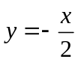.
(a) Determine the first reflected point, P’(x, y). (3)

(b) Find the second reflected point, P’’(x, y). (3)

(c) Show that the second reflected point is a rotation of P(5, 5) about the origin. (2)

END OF SECTION TWO

